License Agreement.
- You are acquiring a license for both reproduction of the copyrighted image below, and for the use of the trademark “Strong Like a Fagot” on specific apparel, US trademark serial number 87247059.
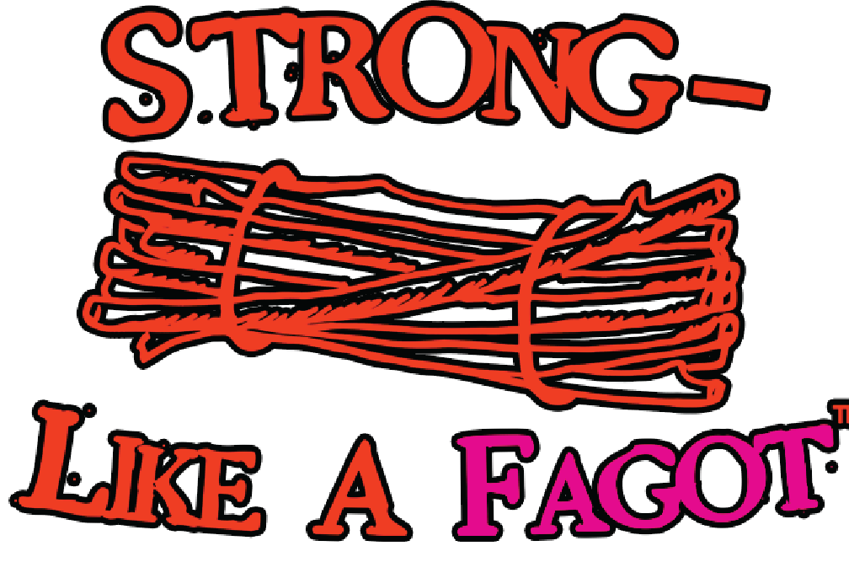

®©

- Upon receipt of your payment of $2 per item of clothing at the CashApp account $sXeDusten, you have purchased a valid license to print the image above on each item. Dusten Blake is the sole copyright owner and the co-owner with his father of trademark, and is authorized to convey the trademark license.
- The license does not include the clothing on which the image is to be printed, nor the costs of finding a printer or printing the image. You assume those costs, and all liability for defects in the printing process.
- The following conditions must be met when you print the image on clothing:
  - The image may not be altered by deleting any portion of it, nor may it be geometrically distorted.
  - The image may be printed in any of 3 different ink combinations:
    - Using a single ink color.
    - Using two ink colors, with one ink reproducing all of the black areas above and the other reproducing all other colored areas
    - Using three ink colors as above, but possibly substituting one different colored ink for all areas of black above; a second colored ink substituting for all the orange areas above ; and a third colored ink substituting for all of the magenta areas above.
- You may also freely copy the image above on unlimited sheets of paper, as long as each printed image meets the following conditions:
  - The entire image above is shown without deletion or distortion.
  - The printed image is not capable of being transferred to any item of apparel.
  - The website URL “StrongLikeAFagot.com” is added, in ink that clearly contrasts with the paper color, and in a size matching the largest letters in the image.
- You may reproduce the image above on any website, as long as it meets the following conditions:
  - The image, and the website URL “StrongLikeAFagot.com”, appear on a single screen when the website is downloaded on an iPhone.
  - The website URL “StrongLikeAFagot.com” is displayed so as to clearly contrast with the screen background color, and in a size matching the largest letters in the image.
- All other rights to reproduction of the copyrighted image are reserved.
- The first 3 stanzas of the 1713 poem “The Fagot” by Jonathan Swift are in the public domain, and may be printed optionally on the apparel without any conditions or restrictions. The image below is a suggestion.
